# CS 255 System Design Document Template

## UML Diagrams

### UML Use Case Diagram

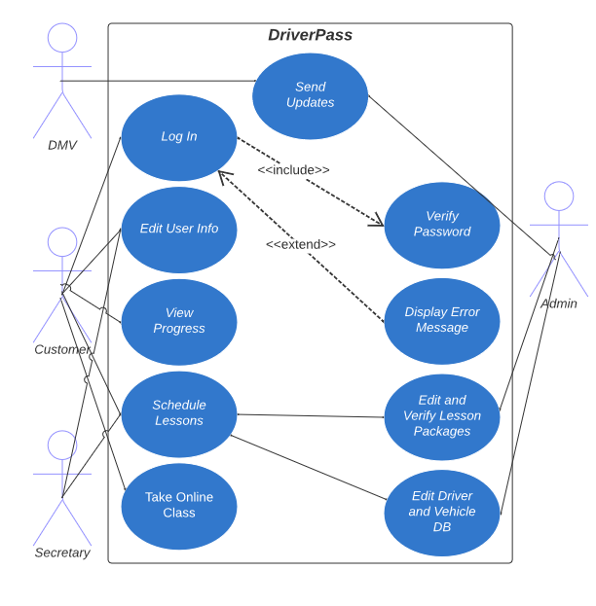

### UML Activity Diagrams

*Scheduling Driving Lessons: Resetting a Password:*

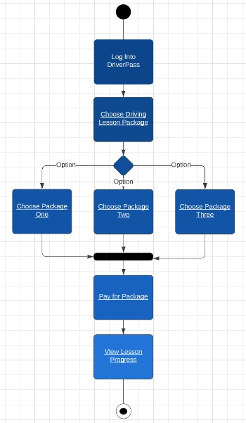

### UML Sequence Diagram

Scheduling Lessons:

### UML Class Diagram

## Technical Requirements

*Hardware:*

* Server
* Monitor
* Computer/mobile device
* Mouse
* Keyboard
* Power source
* Internet

*Software:*

* DriverPass Application
* Security software
* Chosen Operating System
* Internet Browser

*Tools:*

* Programming software
* Internet connection

*Infrastructure:*

* DriverPass location of operation
* Cloud provider
* Connection to DMV
* Insured vehicles
* Third party payment processing